**COMPUTER PROGRAMMING**

**CSL-113**



**PRESENTED BY:**

Zainab Rauf 02-134221-057

**SUBMITTED TO:**

Ms. Soomal Fatima

**DEPARTMENT OF COMPUTER SCIENCE**

**BAHRIA UNIVERSITY, KARACHI CAMPUS**

**PROJECT TITLE**

**Online reservation and restaurant management system**

**TABLE OF CONTENTS:**

|  |
| --- |
| 1. **Abstract** |
| 1. **Summary of project** |
| 1. **Introduction** |
| 1. **Project scope and features** |
| 1. **Flowchart** |
| 1. **Samples screenshots of database** |

**ABSTRACT**

An online ordering system allows customers to order and pay for food with their credit or debit card entirely online. They might ask for delivery or may want to pick the food up from the restaurant themselves.

A restaurant reservation system lets customers reserve a table while restaurateurs oversee bookings, cancellations, and no-shows. Reservation software may also offer waitlist tools, visual table management features or allow you to handle digital pre-payments.

**SUMMARY OF PROJECT**

Going out to have a meal in a good fancy place is something which a lot of people avoid now a days as most of the places with good food are very crowded and in order to eat the delicious food, you have to through the crowd for your number. Another problem that comes with a fancy place is the knife that hangs over your shoulder of how high the bill will be. All the waiting in lines and the tension of the bill prevents you from having a good time. In this project, we have worked upon online food ordering from any place at any time and reservation of restaurants from your comfort zone. Our project is making ease for people, they can choose their best time and book it or they can order online and can pay online.

**INTRODUCTION**

A reservation system helps businesses optimize restaurant seating layouts, so that they can accommodate more customers and give guests more accurate wait times. If the wait becomes longer than anticipated, the host can adjust expectations and offer a complimentary snack or beverage.

Following are the advantages of restaurant reservation system.

* Provide greater convenience for customers.
* Reduce the risk of human error.
* Keep hosts focused on the task at hand.
* Optimize staffing.
* Improve cancellation notifications.
* Capture customer information.

Our proposed system is an online scheduled restaurant reservation and food order system that enables ease for the people. It ends the trouble of traditional queuing system. You can reserve a slot days before the day you have to be there and just walk in as a VIP and sit on the table allotted to you at the time of reservation. Our program also lets you choose a restaurant and place your order at the time of reservation alongside your bill. Moreover, you can choose to get your food delivered at a certain place on your desired date and time. This system improves the method of taking the order from customer. The payment can be made online or pay-on-delivery/arrival system.

**PROJECT SCOPE AND FEATURES**

Our project has following features:

Project for scheduled online restaurant reservation and delivery

• Allows reservation date and time online of your own choice.

• Scheduled dine-in and delivery orders of your choice.

• Lets you choose a restaurant.

• Slot availability.

• Menu and prices of the chosen restaurant.

• Order charges.

• Total bill according to your order.

Order food online and reservation system is a process in which one can order various foods and beverages from some local restaurant and hotels through the use of the internet, just by sitting at home or any place. Online food ordering platforms have disrupted the food ordering and delivery process in restaurants. People no more have to shout for their orders in a crowded restaurant, or especially go out to eat at a restaurant. Furthermore, the online food ordering system for restaurants is a trend that is growing at a fast pace. Major restaurants today just for the convenience factor and increasing revenue are listing their services even online. . Our utmost goal is to make ease for people to buy their choice food at any time from any place and people can choose the menu of their own choice by seeing the discounts on food items.

**FLOWCHART**

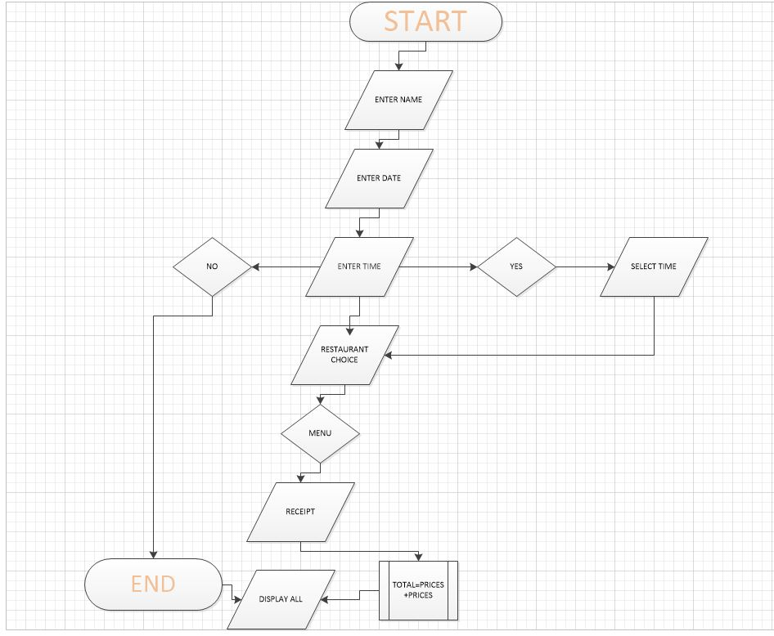

**SAMPLE SCREENSHOTS OF DATABASE**



